22.36: a) For 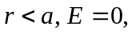since no charge is enclosed.
For 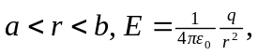 since there is +q inside a radius r.
For 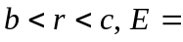0, since now the –q cancels the inner +q.
For 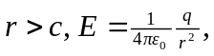 since again the total charge enclosed is +q.
b)
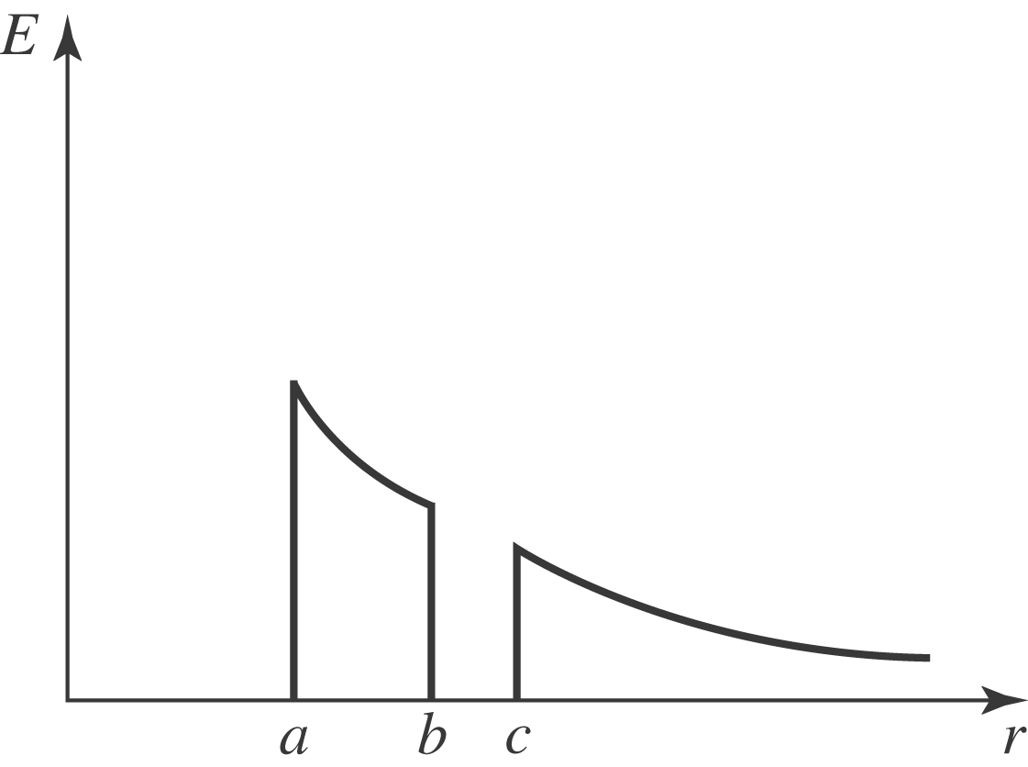
c) Charge on inner shell surface is –q.
d) Charge on outer shell surface is +q.
e)
